**Name: Muhammmad Shoaib Akhter Qadri**

**Enrollment No: 02-131212-009**

**ASSIGNMENT 03**

**TASK NO 1:**

1. **Model the transition system of traffic lights given in Figure # 01 in NuSMV**

MODULE main

VAR

state : {initial, red, warn_red, green, warn_green};

ASSIGN

init(state) := initial;

next(state) :=case

state = initial : red;

state = red : warn_red;

state = warn_red : green;

state = green : warn_green;

state = warn_green : red;

esac;

1. **Print initial state and all reachable states of above transition system using NuSMV**

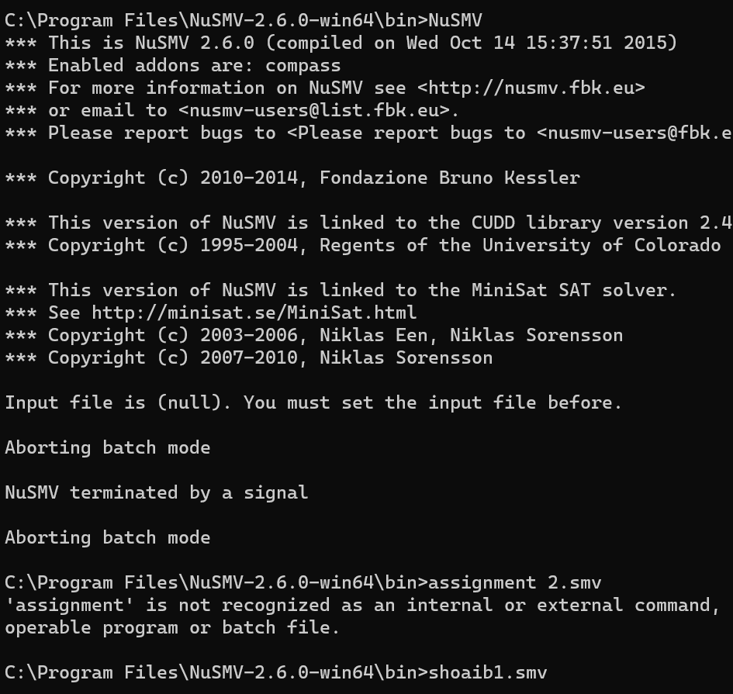

1. **Write the safety property of traffic light system formally and informally.**

**Informally**:

The safety property ensures that if the traffic light is currently displaying a green light, it cannot directly transition to a red or any other light without first transitioning to a warning light to alert drivers of an impending change.

**Formally**:

AG !(state = green & next(state) != warn_green)

**TASK NO 02:**

1. **Model the transition system given in Figure # 02 in NuSMV.**

MODULE main

VAR

req: boolean;

status: {ready, busy};

ASSIGN

init(req) := FALSE;

init(status) := ready;

next(req) := case

status = ready: TRUE;

status = busy: FALSE;

esac;

next(status) := case

req & status = ready: busy;

!req & status = busy: ready;

TRUE: status;

esac;

1. **Print initial state and all reachable states of above transition system using NuSMV**

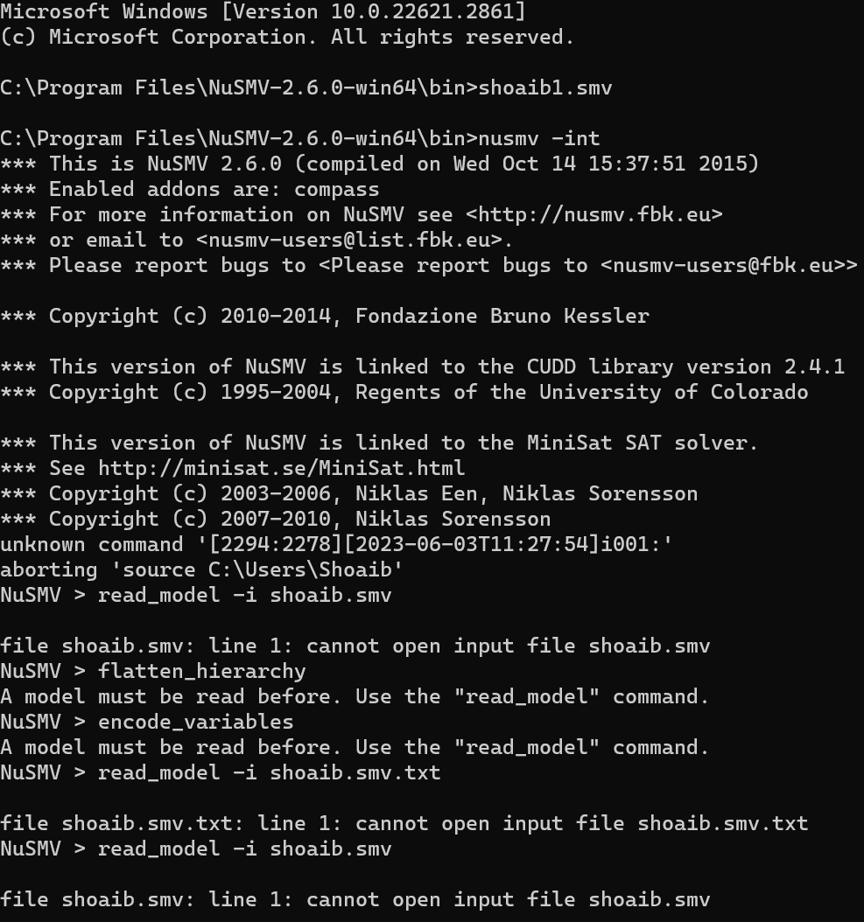

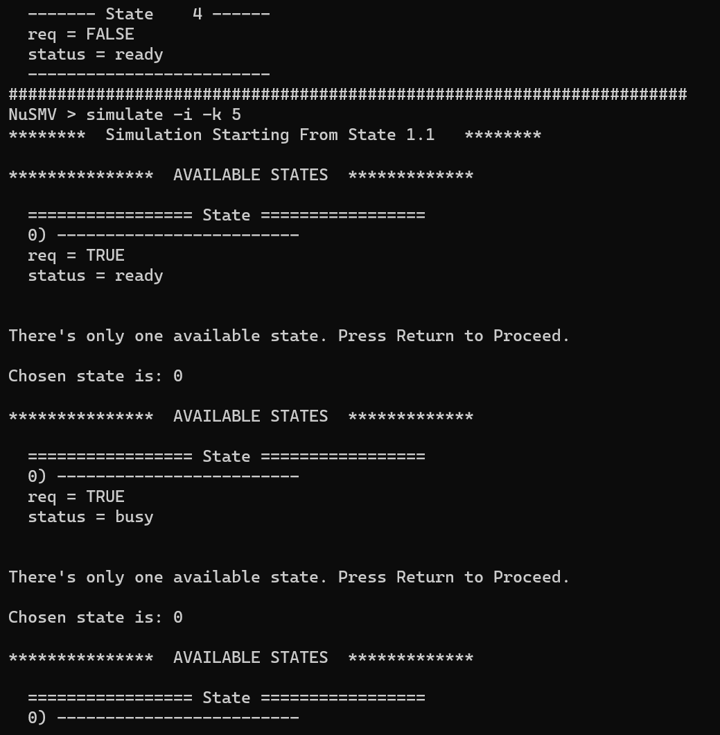

1. **Identify whether the given LTL specification are true or false for the model (Figure2) using NuSMV**
2. G(request -> F status=busy)

**OUTPUT:**

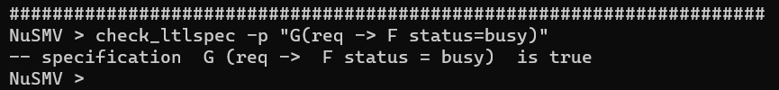

1. X(request = FALSE)

**OUTPUT:**

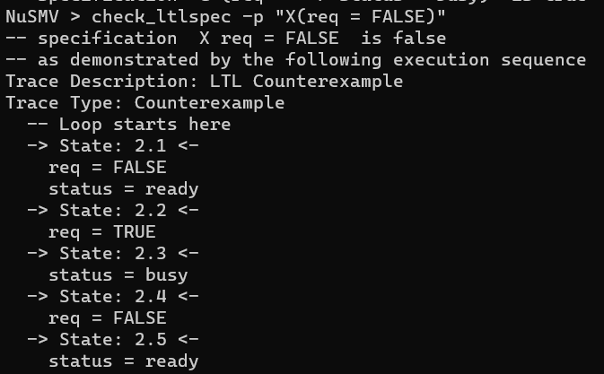

**TASK NO 03:** **Consider a program (given in a C-like language)**

**A) Write all possible (temporal) executions of this program (2 executions are mentioned here)**

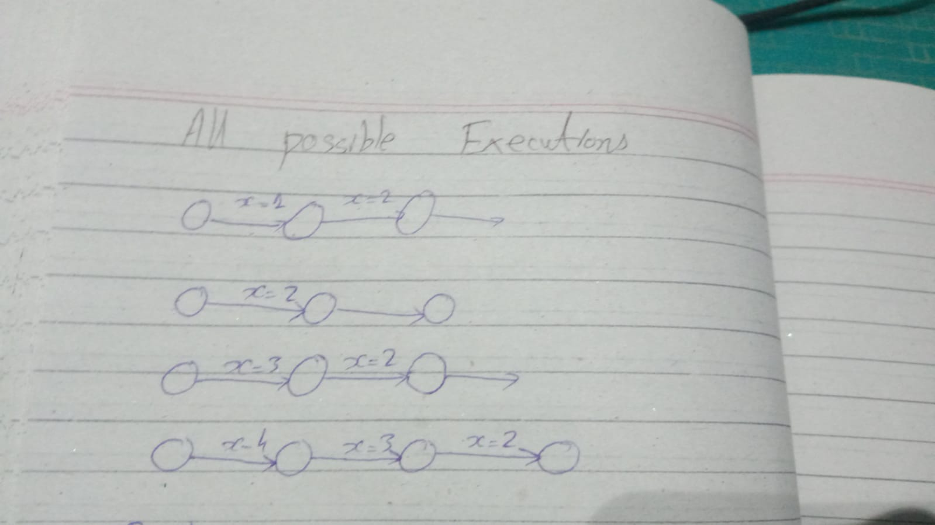

**B) Construct a Büchi Automaton representing all executions of the above program.**

